**How to fix the UCS “Accept or Reject?” Unknown Certificate pop up**

**\*Note, you should use either I.E. or Firefox when connecting to UCS. Safari and Chrome will work, but there are known display and navigation issues. This document covers I.E. and Firefox only**

**For I.E:**

Point your web browser to either the UCS 60 oxford St or 1 Summer St. environment:

60 Oxford: <https://10.34.6.50/>

Summer St: <https://10.34.200.50/>

You will notice a certificate error next to the address bar:



Click on the “X” next to Certificate error and select “View certificates”

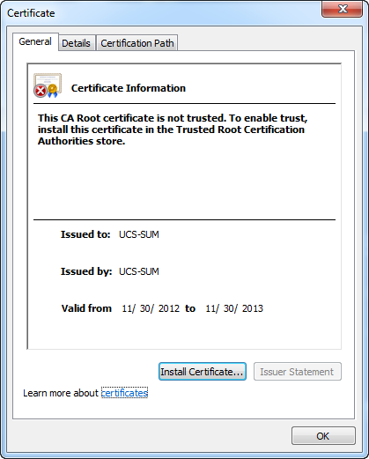

Click “Install Certificate” When the Certificate Import Wizard opens, click “Next”

Select “Place all certificates in the following store” and Click “Browse”.

Highlight the “Trusted Root Certification Authorities” store:

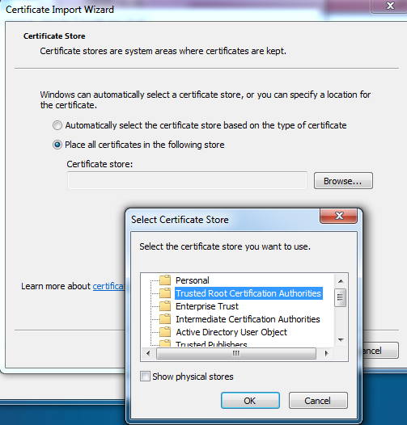

Click “OK”, then click “next” and then “Finish”

A pop up box similar to the one below will appear. Click “yes”

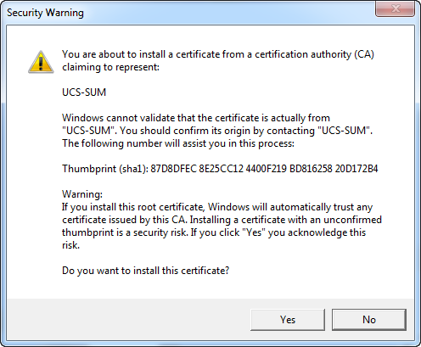

**For Firefox:**

Open Firefox

Click “Alt” and select “Tools>Options”” from the Firefox Menu

Click “Advanced”. In Certificate Manager, select the “Servers” tab

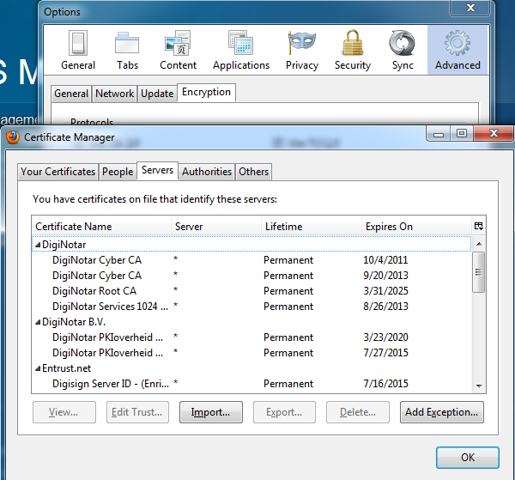

Click “Add Exception” Enter one of the URL’s below

60 Oxford: <https://10.34.6.50/>

Summer St: <https://10.34.200.50/>

Click “Get Certificate”, make sure “Permanently store this exception” is selected and click “Confirm Security Exception”.

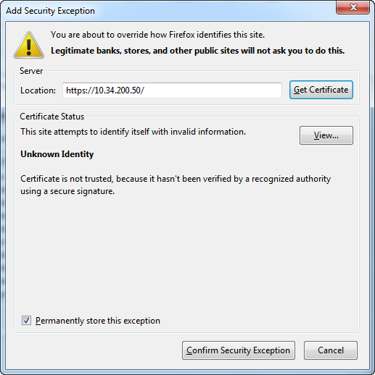

Click “OK” and then “OK” again to exit.